Project Title
Amazon Music Clustering using K-Means Clustering and Recommendation System

1. Introduction
Music streaming platforms contain millions of songs with different audio characteristics. Grouping similar songs helps users discover music that matches their preferences and enables recommendation systems.
The objective of this project is to cluster songs based on their audio features using the K-Means clustering algorithm. The resulting clusters represent different styles of music, and the trained model is further used in a Streamlit application to recommend similar songs based on Euclidean distance.

2. Objectives
- Perform exploratory data analysis on the Amazon Music dataset.
- Select relevant audio features for clustering.
- Normalize the selected features.
- Determine the optimal number of clusters using multiple evaluation techniques.
- Build a K-Means clustering model.
- Analyze and assign meaningful names to each cluster.
- Visualize the clustering results.
- Save the trained model and scaler.
- Develop a Streamlit application that predicts a song cluster and recommends similar songs.

3. Dataset Description
Attribute | Value
Dataset | Amazon Music Dataset
Total Records | 95,837
Total Columns | 23
Float Columns | 10
Integer Columns | 7
String Columns | 6
Missing Values | None
Duplicate Records | None
The dataset contains audio characteristics and metadata for Amazon Music tracks.

4. Exploratory Data Analysis
The dataset was examined before model development.

Findings
- Dataset contains 95,837 songs.
- Total of 23 attributes.
- No missing values were found.
- No duplicate records were found.
- Numerical and categorical variables were properly formatted.
- The dataset was ready for clustering without additional cleaning.

5. Feature Selection
The following nine audio features were selected because they describe the musical characteristics of each song.
S. No. | Selected Features
1 | Danceability
2 | Energy
3 | Loudness
4 | Speechiness
5 | Acousticness
6 | Instrumentalness
7 | Liveness
8 | Valence
9 | Tempo
These features directly represent the musical behavior of a track and are widely used for music recommendation systems.

6. Feature Scaling
Since the selected features have different value ranges, StandardScaler was applied.
Feature scaling ensures:
- Equal contribution of every feature.
- Better distance calculation.
- Improved K-Means clustering performance.
- Faster convergence.

7. Selecting the Optimal Number of Clusters
Several values of K (2–10) were tested using three evaluation techniques:
- Elbow Method (WCSS)
- Silhouette Score
- Davies-Bouldin Index (DBI)
The evaluation results are shown below.
Rank | K | WCSS | WCSS Reduction (%) | Silhouette Score | DBI | Overall Rank
1 | 4 | 507,958.11 | 11.40 | 0.2394 | 1.4638 | 6
2 | 3 | 573,286.79 | 16.42 | 0.2494 | 1.5169 | 7
3 | 9 | 366,813.54 | 5.36 | 0.1828 | 1.4526 | 13
4 | 5 | 464,185.95 | 8.62 | 0.1960 | 1.6164 | 14
5 | 8 | 387,592.12 | 5.78 | 0.1828 | 1.5102 | 15
6 | 7 | 411,371.56 | 5.93 | 0.1751 | 1.5432 | 17
7 | 10 | 353,306.28 | 3.68 | 0.1749 | 1.4732 | 19
8 | 2 | 685,950.97 | -1.00 | 0.2102 | 1.8692 | 21
9 | 6 | 437,304.11 | 5.79 | 0.1691 | 1.6251 | 22

Observation
Although K = 3 produced the highest Silhouette Score, K = 4 provided:
- Better overall ranking
- Better cluster interpretation
- More meaningful separation of music styles
- Better business usability
Therefore, K = 4 was selected as the final clustering model.

8. Comparison Between K = 3 and K = 4
Both clustering solutions were analyzed.

K = 3
Cluster | Description
0 | Mixed energetic songs
1 | Speech and narration audio
2 | Acoustic songs
Although the clustering quality was good, instrumental music was merged with acoustic music.

K = 4
The fourth cluster successfully separated instrumental tracks from acoustic tracks, making the clustering easier to interpret and more suitable for recommendations.

9. Cluster Analysis (K = 4)
Average feature values for each cluster are shown below.

K | Danceability | Energy | Loudness | Speechiness | Acousticness | Instrumentalness | Liveness | Valence | Tempo
0 | 0.505 | 0.343 | -12.077 | 0.058 | 0.697 | 0.018 | 0.180 | 0.427 | 113.585
1 | 0.635 | 0.708 | -7.414 | 0.078 | 0.242 | 0.021 | 0.201 | 0.686 | 125.297
2 | 0.664 | 0.465 | -13.466 | 0.835 | 0.591 | 0.001 | 0.441 | 0.581 | 100.038
3 | 0.485 | 0.415 | -13.969 | 0.060 | 0.648 | 0.811 | 0.189 | 0.450 | 114.250

10. Cluster Naming
To assign meaningful labels, two approaches were followed:
- Randomly inspected ten songs from each cluster.
- Compared the average feature values of each cluster.
Based on this analysis, the following names were assigned.
Cluster | Assigned Name
0 | Acoustic & Melodic Music
1 | Energetic & Danceable Music
2 | Speech & Narration Audio
3 | Instrumental & Ambient Music
These names closely represent the dominant characteristics of each group.

11. Visualizations
The following visualizations were created to interpret the clustering results.

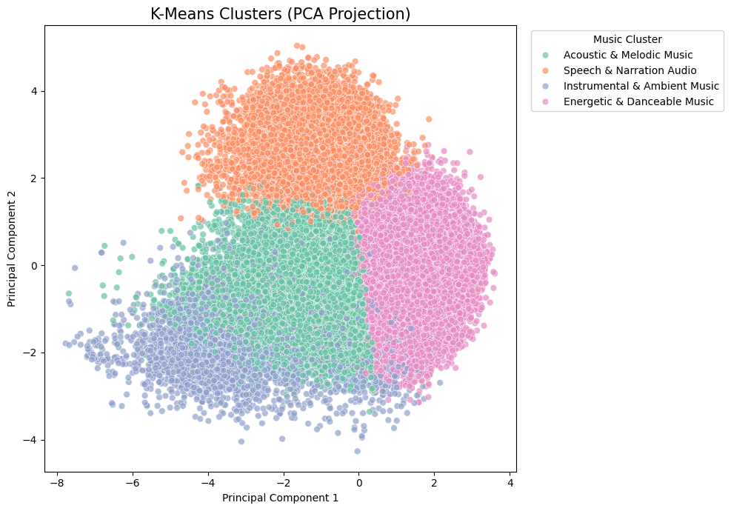

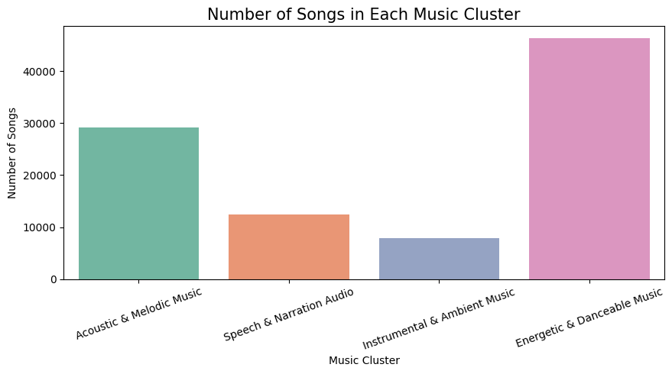

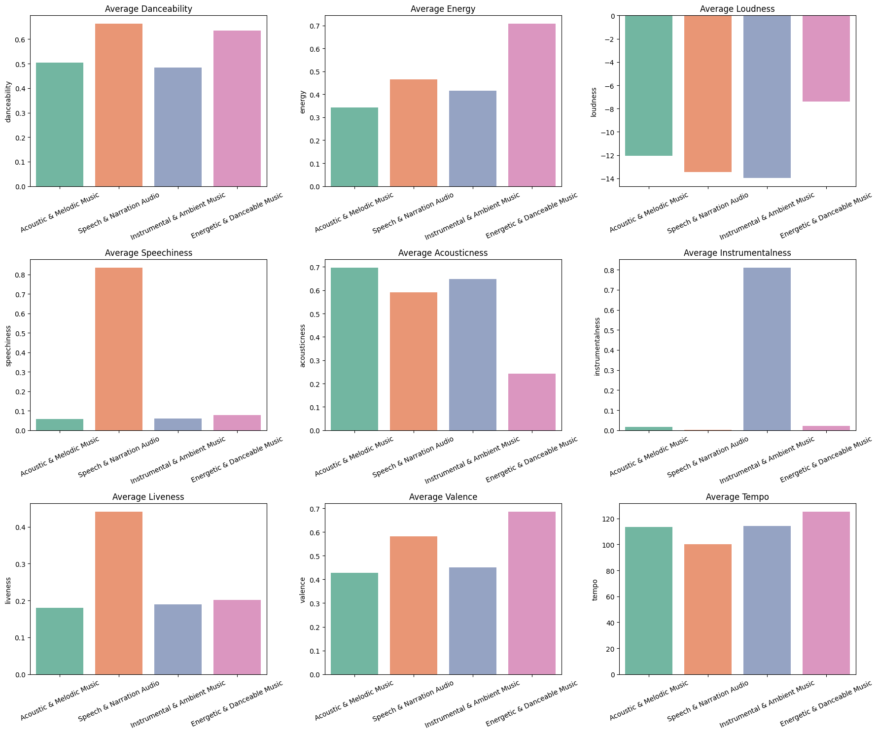

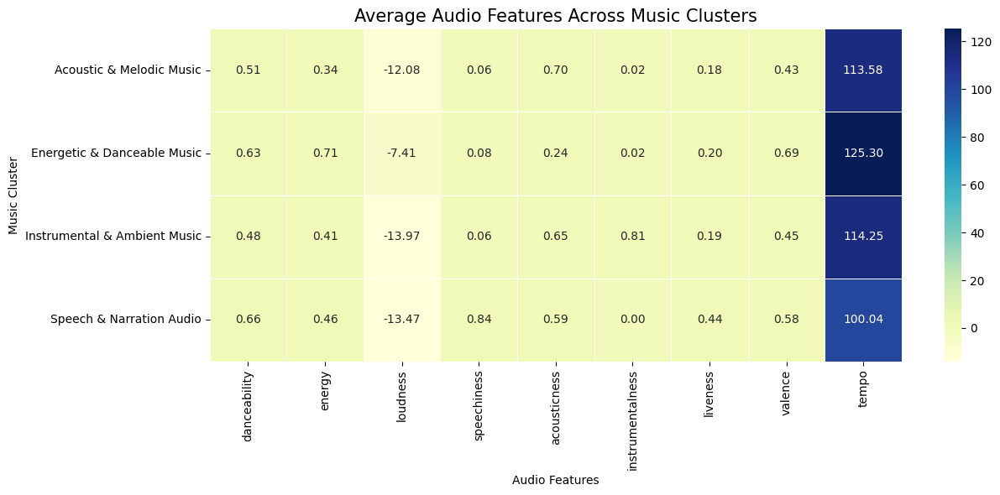

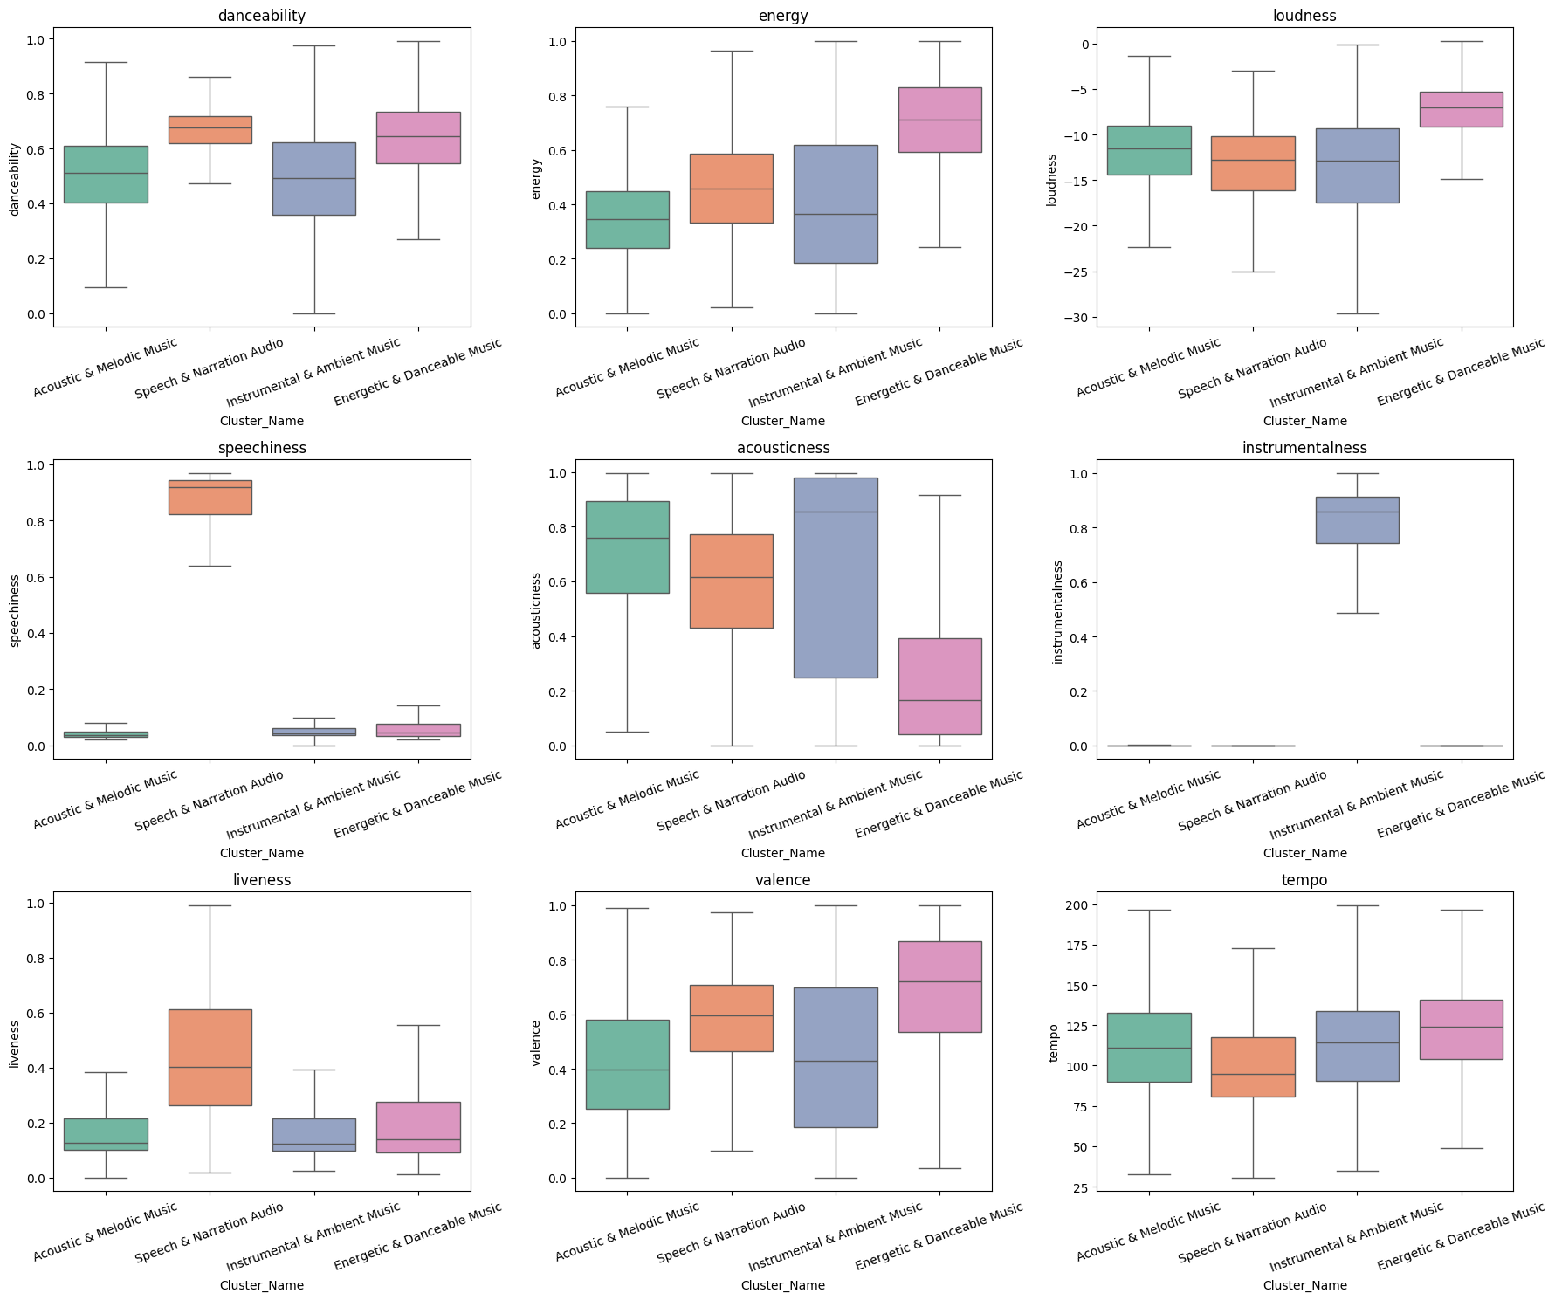

These visualizations helped validate cluster separation and understand feature distributions.

12. Model Saving
The trained objects were saved using the Pickle library.
Saved files include:
- K-Means Model
- StandardScaler
Saving the model allows future predictions without retraining.

13. Streamlit Application
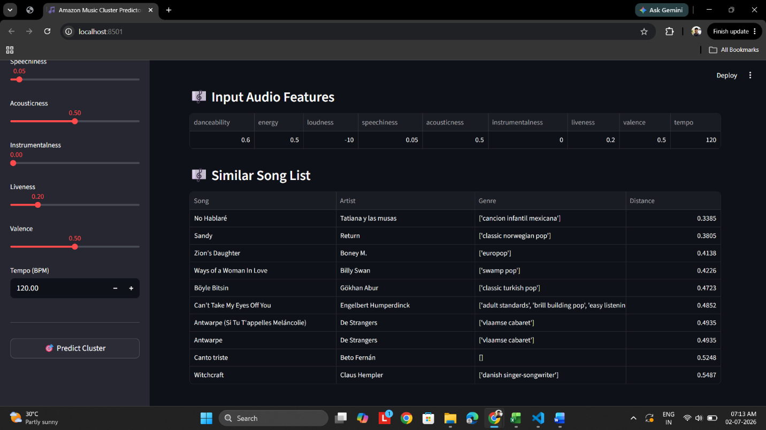
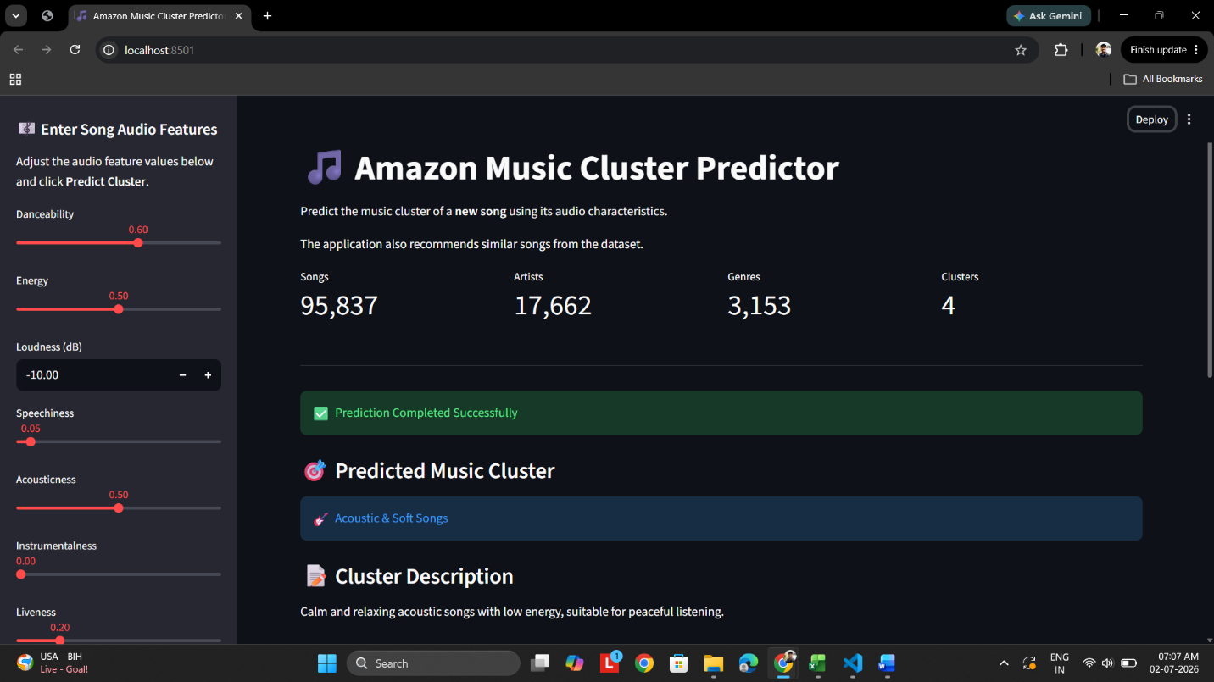
A Streamlit web application was developed to demonstrate the clustering model.

Workflow
- User enters values for the nine audio features.
- The inputs are converted into a DataFrame.
- The saved Standard Scaler scales the input.
- The trained K-Means model predicts the music cluster.
- Songs belonging to the predicted cluster are filtered from the dataset.
- Euclidean distance is calculated between the user input and songs within the same cluster.
- The top 10 nearest songs are recommended based on the smallest Euclidean distance.

This provides a simple content-based music recommendation system.

14. Results
- Successfully clustered 95,837 songs into four meaningful groups.
- K = 4 provided the best balance between clustering quality and interpretability.
- Meaningful cluster names were assigned through feature analysis and song inspection.
- A recommendation engine based on Euclidean distance was successfully implemented.
- A Streamlit application was developed for interactive predictions and song recommendations.

